**C23 Ex01 Yael 315242974 Amit 207040254**

**Explanations and Features:**

Basic Features:

1. Liked Pages Display – Presents a collection of pages that the user has liked.

2. Friends List – Shows the user's list of friends.

3. User Profile Picture – Reveals the user's profile picture and name.

4. Posts – Displays a list of the user's posted content.

5. Album – Highlights the titles and cover images of the user's albums.

New Features:

1. Guess the Posting Year – This feature randomly selects a post from the user's collection and the user needs to guess the year when the post was originally uploaded.

- Can be found at 'PostsToYears.cs' class.

2. Time Travel: Past View – Display albums, posts, and cover images of a chosen album that the user uploaded in a year they personally select.

- Can be found at 'PastView.cs' class.

**Use case diagram:**

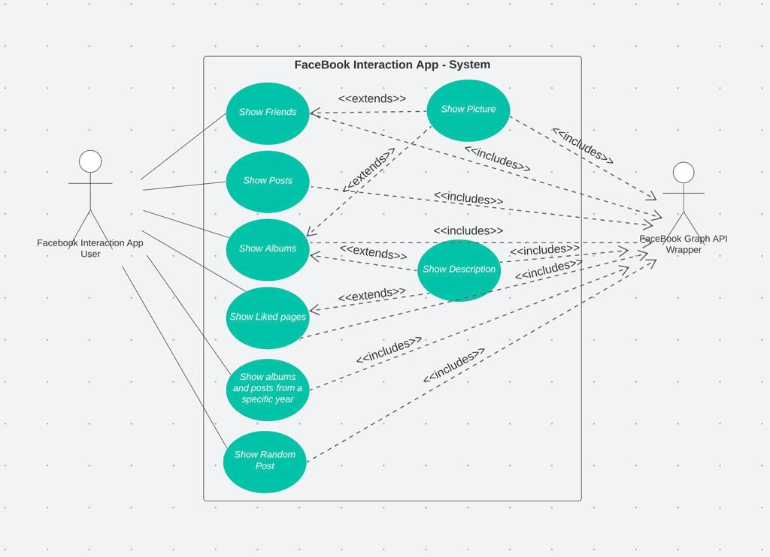

**Class diagram:**

**Sequence diagrams:**

1. Guess the Posting Year

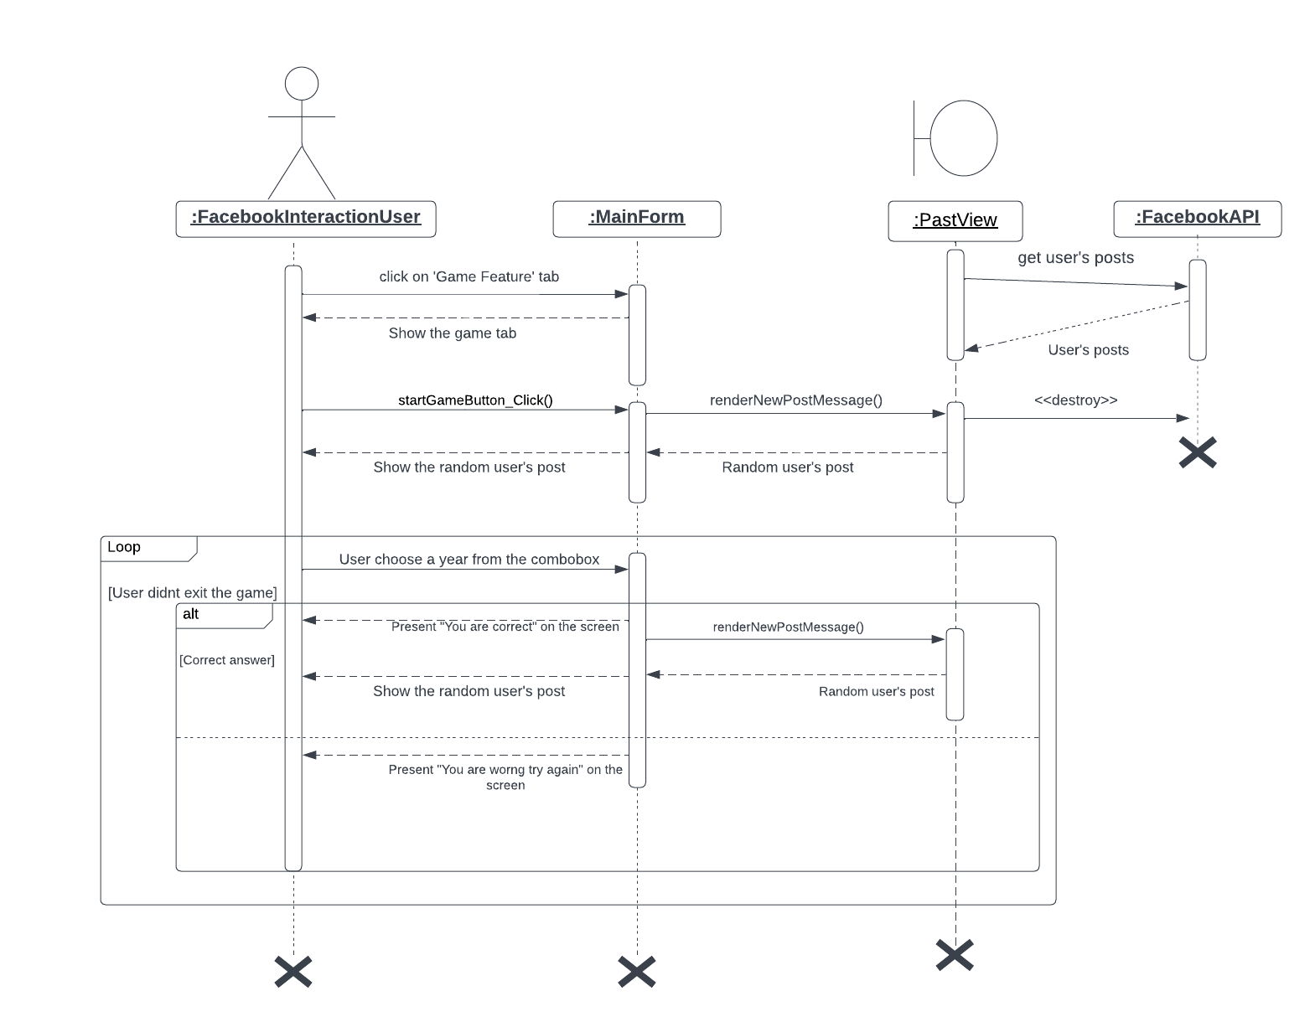

2. Time Travel: Past View

